Jammming Feature Request:

Pressing enter triggers a search

**May 15, 2018**

# **OBJECTIVE**

We will update the Jammming app with functionality to execute a search by hitting enter on the keyboard rather than clicking the search button.

# **BACKGROUND**

The ability to hit enter to submit a field after typing text (also known as implicit submission) is now an intuitive expectation in the user experience-- when that capability isn’t there, it feels like an annoying extra step. I have personally been frustrated while testing the Jammming app during development that I have to switch from the keyboard to touchpad in order to submit the search, so the decision to implement this feature was an obvious choice. While I imagine this functionality would feel less necessary on a mobile/other touch screen version of the application, it would be nice to have both options there, and feels like an absolute necessity on a traditional laptop or desktop. It’s a simple change that in its inclusion won’t probably be noticed by most users, but that will make for a more seamless user experience, and that improves accessibility for users of different abilities.

# **TECHNICAL DESIGN**

Implementation of this feature will be fairly straightforward. In order to trigger the search function with the enter key, we will simply need to update the SearchBar component to include an additional event listener to trigger the search function once the enter button is hit. To implement this listener, we will first need a handler function added as a method to the searchBar component. It listens for a keyPress, and *if* the key pressed is the enter key, it will execute a search like so:

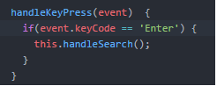

After that, it’s simply a matter of adding the handler to the input field in the component’s render statement, and remembering to bind ‘this’ to it in the constructor: 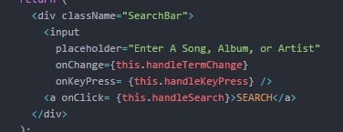

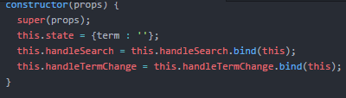

# **CAVEATS**

There are many people opposed to implicit submission, as it can lead to unintended or premature data submission. One such opponent has even developed a Chrome extension to prevent web pages from submitting input fields when enter is pressed. I recognize that this functionality is not always helpful, and in some instances can be detrimental, however in the limited scope of this simple application, there really shouldn’t be any issues in implementing this change, which I believe most users have come to expect and prefer. The search button will remain functional for anyone who wishes to submit with a click rather than hitting enter, so nothing will be lost for those users whose preferences are different from my own. Furthermore, according to HTML5 standards, implicit submission is an accessibility best practice, working with adaptive software to help the web become more easily accessible to everyone.